**The Fahua Gourd Vase**

The Fahua Gourd Vase ***[Fig. 1]*** is a porcelain masterpiece made about 500 years ago, during the Ming Dynasty (c. 1530) in China. Made in Jingdezhen, the centre of China's highest porcelain craftsmanship, this piece of art features unique techniques including Fahua enamel. These imagery, materials, and techniques reflect the cultural context, economic conditions, and political environment of China's Ming Dynasty.

Fig. 1. The Fahua Gourd Vase, Ming Dynasty (c. 1530)

Traditional Chinese gourd vases are usually made with a small top and a large bottom ***[Fig. 2]***, Shaped like a plant gourd. It is one of the typical forms of utensils in ancient China, because the word for gourd (húlu) in the Chinese language is a homophone for 'fortune and prosperity' (fúlù). The surface of the Fahua gourd vase is bright and smooth, the raised white patterns are filled with blue, yellow, and purple enamels. The main color of this vase is blue, also known as peacock blue, which is one of the main enamel colors of traditional Chinese Fahua objects. The blue color is often derived from nature, such as the sea and the sky. Provides a sense of luxury and elegance. Chinese enamelware comes in two types of blue glazes: peacock blue ***[Fig. 3]*** and indigo ***[Fig. 4]***. Other common colors are yellow and purple. Like the Long[1] pattern on this vase is bright yellow. Yellow has a high status in Chinese culture which is a symbol of kings. The monopoly of yellow by kings also represents a privilege and has influenced folk aesthetics.

Fig. 2. Eight Immortals Across the Sea Fahua gourd-shaped bottle,

Ming Dynasty (c. 15th-16th), 43.5cm*26cm

Fig. 3. (left) A pair of blue and gold painted ceramic jars,

Ming Dynasty (c. 15th-16th)

Fig. 4. (right) Fahua Eight Immortals Pattern big pot,

Ming Dynasty (c. 1506-1566)

In addition, the Long pattern is also an important symbol of royal power. In ancient China, only the emperor's utensils and costumes could use Longs as decoration, so it can be assumed that this vase was a royal utensil. However, it is notable that each Long's claw in this vase has been wiped off a finger ***[Fig. 5]***. In Chinese culture, there are two sacred animals, the Long and the python; the one with five fingers is the Long and the one with four fingers is the python ***[Fig. 6]***. The Long had a higher status and only the emperor could use it. Princes could only use pythons for decoration. Princes could only use pythons for decoration, and the finger count was an important feature in distinguishing the two sacred animals. So these missing fingers might imply a struggle about positions of power. The last main visual feature is clouds. In Chinese myth, Longs fly with the clouds, and purple clouds specifically symbolize good fortune. In short, the visual elements of this vase all highlight the noble status of the owner and the aesthetic preferences of the royal.

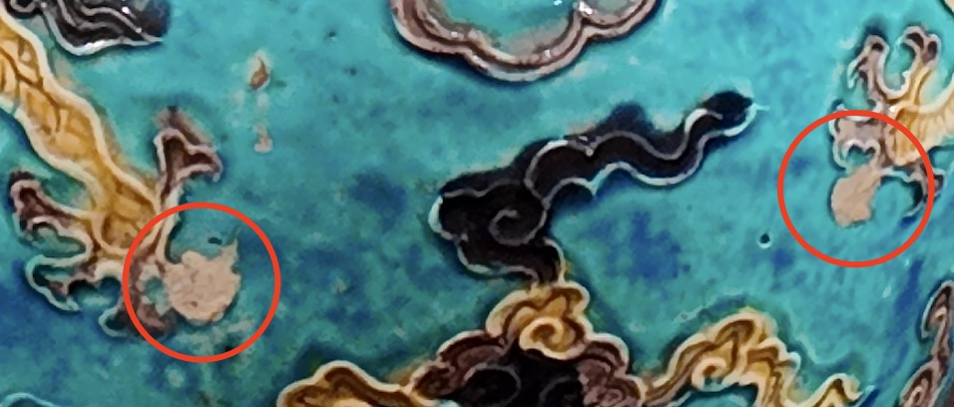

Fig. 5. The Fahua Gourd Vase (Part), Ming Dynasty (c. 1530)

Fig. 6. Long and Python. Long on the left and Python on the right.

Making the Fahua gourd vase needs special materials and complex process. This process began in the yuan dynasty (1271-1368), reached peak in the Ming dynasty[2]. Fahua technology evolved from colored glaze, which at that time was single in color, while Fahua had more colors. And respectively represented by Shanxi in the north and Jingdezhen in the south.Shanxi Fahua is based on pottery as the main material, easy to age and wear. In contrast, Jingdezhen replaced pottery with porcelain, which is more beautiful and easier to preserve. Jingdezhen's production method is to use a brush dipped in mud to outline lines, high temperature firing into a complete porcelain base. Then fill the raised outline with various colors of low-temperature glaze, and finally the second firing[3].In this process, the biggest difficulty is the glaze production. In fact, the peacock blue glaze used in this gourd vase comes from West Asia ***[Fig.7]***. In the Yuan Dynasty, the Mongol Empire restarted the Silk Road to promote trade between China and West Asian countries, so this special low-temperature colored glaze spread to China and began production in the middle Yuan Dynasty[4]. Such international trade facilitated the exchange of techniques. The economy of the Ming Dynasty also became rich based on the development of international trade and handicrafts, thus luxury handicrafts such as Fahua were promoted and developed during this period.

In sum, the visual elements and material craftsmanship of the artwork not only represent the cultural background of the time, but also imply the economic conditions and political policies of the region.

Fig.7 Peacock blue glazed plate made in Iran, 12th-13th century.

**Bibliography**

Guizhen Huang. Ming Dynasty Fahua ware collected by Shanxi History Museum [J]. Cultural Heritage, 1997 (4): 67-69.

Tu, Zhihao. “Research on the Characteristics and Inheritance of Fa Hua Color.” *Chinese Ceramics* 50, no. 8 (August 2014): 73–77. <https://doi.org/10.16521/j.cnki.issn.1001-9642.2014.08.022>.

Xiamen University news network. “The Traditional Chinese Color | Peacock Blue in the Museum Is like Blue in the Water - Xiamen University News Network .” Xmu.edu.cn, 2023. https://news.xmu.edu.cn/info/1047/448271.htm.

1. “Long” is the Chinese “dragon” being a mythical creature symbolizing power and auspiciousness, often depicted as a wingless, serpentine creature. In the West, the dragon is usually a winged, symbolizing destruction and danger. Therefore, the dragon in this article will use the Chinese pronunciation “Long’ instead.
2. Guizhen Huang. Ming Dynasty Fahua ware collected by Shanxi History Museum [J]. Cultural Heritage, 1997 (4): 67-69.
3. Zhihao Tu, “Research on the Characteristics and Inheritance of Fa Hua Color,” Chinese Ceramics 50, no. 8 (August 2014): 73–77, https://doi.org/10.16521/j.cnki.issn.1001-9642.2014.08.022.
4. Xiamen University news network, “The Traditional Chinese Color | Peacock Blue in the Museum Is like Blue in the Water - Xiamen University News Network ,” Xmu.edu.cn, 2023, https://news.xmu.edu.cn/info/1047/448271.htm.